Chapter 6 Problems 6.5-6.8  
Brand Preference

### Ahmad M. Osman

A small-scale experimental study was conducted of the relation of degree of brand liking (Y) vs. moisture content (X1) and sweetness (X2) of a product. The scatterplot matrix and correlation matrices appear below.

mydata <- read.table(file.choose(),header=F,col.names=c("Y", "X1", "X2"))  
  
x1name = "Moisture Content"  
x2name = "Sweetness"  
yname = "Brand Preference"   
  
attach(mydata)  
  
plot.new()  
plot (mydata)

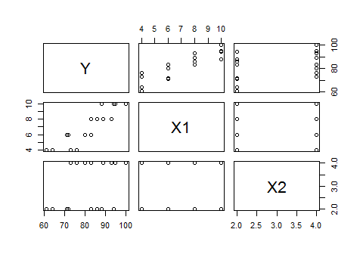

plot (mydata, col=ifelse(X2==2, 'blue', 'red'))

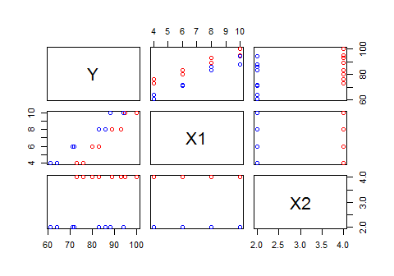

cor (mydata)

## Y X1 X2  
## Y 1.0000000 0.8923929 0.3945807  
## X1 0.8923929 1.0000000 0.0000000  
## X2 0.3945807 0.0000000 1.0000000

Summarize the scatterplot matrix and correlation matrix...

In the scatterplot matrix above the bivariate relationships for each predictor and response variable is shown. The most significant relationships seem to be between Brand Preference and Moisture Content (Y and X1). In addition to that, the correlation matrix shows the correlation coefficients for each bivariate relationship. The most significant relationships from the correlation matrix seem to also be between Brand Preference and Moisture Content (Y and X1) with a correlation coefficient equal to 0.8923929. Both matrices indicate that the relationship between sweetness and brand preference is not very significant.

Next, a multiple regression model is fit to the data:

myfit <- lm (Y ~ X1 + X2)  
myfit

##   
## Call:  
## lm(formula = Y ~ X1 + X2)  
##   
## Coefficients:  
## (Intercept) X1 X2   
## 37.650 4.425 4.375

confint(myfit, level=0.95)

## 2.5 % 97.5 %  
## (Intercept) 31.177312 44.122688  
## X1 3.774470 5.075530  
## X2 2.920372 5.829628

summary(myfit)

##   
## Call:  
## lm(formula = Y ~ X1 + X2)  
##   
## Residuals:  
## Min 1Q Median 3Q Max   
## -4.400 -1.762 0.025 1.587 4.200   
##   
## Coefficients:  
## Estimate Std. Error t value Pr(>|t|)   
## (Intercept) 37.6500 2.9961 12.566 1.20e-08 ***  
## X1 4.4250 0.3011 14.695 1.78e-09 ***  
## X2 4.3750 0.6733 6.498 2.01e-05 ***  
## ---  
## Signif. codes: 0 '***' 0.001 '**' 0.01 '*' 0.05 '.' 0.1 ' ' 1  
##   
## Residual standard error: 2.693 on 13 degrees of freedom  
## Multiple R-squared: 0.9521, Adjusted R-squared: 0.9447   
## F-statistic: 129.1 on 2 and 13 DF, p-value: 2.658e-09

The estimated regression function is: Yi = 37.65 + 4.425X1 + 4.375X2

The interpretations of $b_{1}$ and $b_{2}$ are: $b_{1}$ represents the change in the mean of responses per unit increase in moisture content when sweetness is kept constant. $b_{2}$ represents the change in the mean of responses per unit increase in sweetness when moisture content is kept constant.

resid = myfit$residuals  
fitted = myfit$fitted.values  
  
plot.new()  
boxplot (resid)

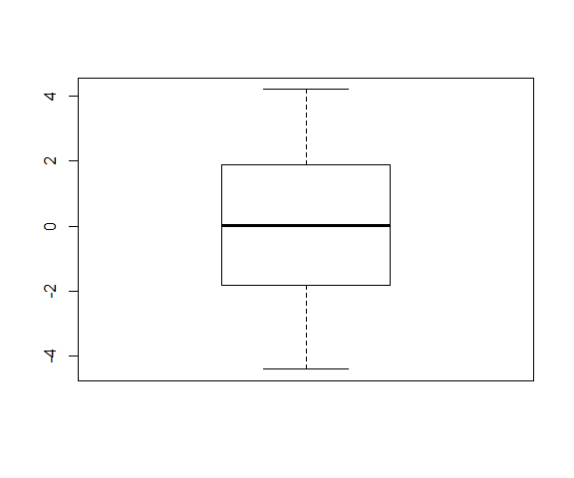

The box plot tells us...

The data is, relatively speaking, normally distributed and has a constant variance with no obvious outliers found.

par(mfrow=c(1,2))  
  
plot (fitted, resid, xlab="Fitted Values", ylab="Residuals", col='blue')  
abline(h=0, col='red')  
  
plot (X1, resid, xlab=x1name, ylab="Residuals", col='blue')  
abline(h=0, col='red')

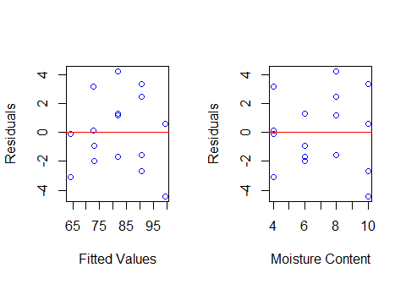

plot (X2, resid, xlab=x2name, ylab="Residuals", col='blue')  
abline(h=0, col='red')  
  
mydata$X1X2 = X1 * X2  
plot (mydata$X1X2, resid, xlab="X1 * X2 Interaction", ylab="Residuals", col='blue')

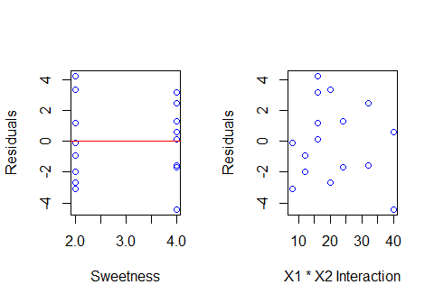

These residual plots above tell us: that it seems like there is a constant variance, a linear relationship, and no obvious outliers found in both the residuals vs fitted values and the residuals vs the moisture content. In addition to that, the plots of residuals vs sweetness and resiuals vs X1*X2 are not as clear, but show that no obvious outliers were found.

plot.new()  
par(mfrow=c(1,2))  
plot (fitted, abs(resid), xlab="Fitted Values", ylab="Absolute Residuals", col='blue')  
low1 = lowess (fitted, abs(resid))  
lines (low1$x, low1$y, col='red')  
  
qqnorm (resid, col='blue')  
qqline (resid, col='red')

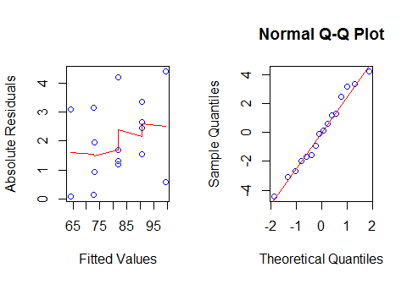

These plots tell us...

The Absolute Residuals vs Fitted Values plot show that there is no constant variance. The Normal Q-Q Plot shows that the data is, relatively speaking, normally distributed and that there are no obvious outliers found.

plot.new()  
par(mfrow=c(1,1))  
plot (fitted, Y, xlab=paste("Fitted", yname), ylab=yname, col='blue', main="Observed Response vs Fitted Values")  
abline(0, 1, col='red')  
  
# Working-Hotelling limits (confidence band for the regression line)   
  
error.df = summary(myfit)$df[2]  
num.pred = summary(myfit)$df[1]  
  
fcrit <- qf (0.95, num.pred, error.df)   
#pred <- predict (myfit, mydata [, c("X1", "X2")], se.fit=TRUE)   
wh.fit = lm (Y ~ fitted)  
wh.pred = predict (wh.fit, data.frame (fitted = wh.fit$fitted.values), se.fit=TRUE)   
wh.fitted = wh.pred$fit   
  
w <- sqrt (num.pred * fcrit)   
marg.err <- w * wh.pred$se.fit   
  
# Sort the fitted values from smallest to largest  
wh.order = order (wh.fitted)  
wh.ordered = wh.fitted [wh.order]  
  
wh.lower = wh.ordered - marg.err [wh.order]  
wh.upper = wh.ordered + marg.err [wh.order]  
  
lines (wh.ordered, wh.lower, lty=2, col='red')  
lines (wh.ordered, wh.upper, lty=2, col='red')

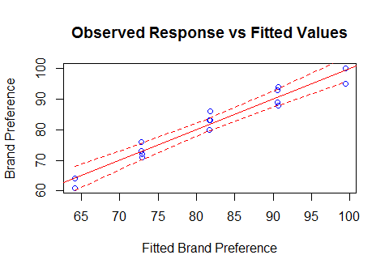

# Breusch-Pagan test  
library(lmtest)

## Warning: package 'lmtest' was built under R version 3.4.2

## Loading required package: zoo

## Warning: package 'zoo' was built under R version 3.4.2

##   
## Attaching package: 'zoo'

## The following objects are masked from 'package:base':  
##   
## as.Date, as.Date.numeric

bptest(myfit, studentize=FALSE)

##   
## Breusch-Pagan test  
##   
## data: myfit  
## BP = 1.0422, df = 2, p-value = 0.5939

The alternatives here are H0: y1 = 0, and Ha: y1 ≠ 0 where y1 = 0 corresponds to the constancy of error variance. The decision rule is that if p-value > 0.01 then we conclude H0, otherwise we conclude Ha.

The Breusch-Pagan test indicates that BP is equal to 1.0422 with a p-value equal to 0.5939 and a level of significance set to 0.01. With that in mind, we conclude H0 which is the constancy of variance.

# Lack of fit test  
# How many levels of X1 combined with X2?  
  
aggregate (Y, by=list(X1, X2), FUN='mean')

## Group.1 Group.2 x  
## 1 4 2 62.5  
## 2 6 2 71.5  
## 3 8 2 84.5  
## 4 10 2 91.0  
## 5 4 4 74.5  
## 6 6 4 81.5  
## 7 8 4 91.0  
## 8 10 4 97.5

# Fit the full model:  
full = lm (Y ~ 0 + as.factor(X1) * as.factor(X2))  
anova (myfit, full)

## Analysis of Variance Table  
##   
## Model 1: Y ~ X1 + X2  
## Model 2: Y ~ 0 + as.factor(X1) * as.factor(X2)  
## Res.Df RSS Df Sum of Sq F Pr(>F)  
## 1 13 94.3   
## 2 8 57.0 5 37.3 1.047 0.453

The alternatives here are

* H0: The relationship assumed in the model is reasonable (there is no lack of fit)
* Ha: The relationship assumed in the model is not reasonable (there is lack of fit)

Using a level of significance of 0.01, the decision rule says that if the p-value > 0.01, then we conclude an appropriate fit, and if the p-value < 0.01, then we conclude a lack of fit.

The lack of fit test indicates a p-value of 0.453 which is greater than 0.01, indicating an appropriate fit (a lack of 'lack of fit').

summary(myfit)

##   
## Call:  
## lm(formula = Y ~ X1 + X2)  
##   
## Residuals:  
## Min 1Q Median 3Q Max   
## -4.400 -1.762 0.025 1.587 4.200   
##   
## Coefficients:  
## Estimate Std. Error t value Pr(>|t|)   
## (Intercept) 37.6500 2.9961 12.566 1.20e-08 ***  
## X1 4.4250 0.3011 14.695 1.78e-09 ***  
## X2 4.3750 0.6733 6.498 2.01e-05 ***  
## ---  
## Signif. codes: 0 '***' 0.001 '**' 0.01 '*' 0.05 '.' 0.1 ' ' 1  
##   
## Residual standard error: 2.693 on 13 degrees of freedom  
## Multiple R-squared: 0.9521, Adjusted R-squared: 0.9447   
## F-statistic: 129.1 on 2 and 13 DF, p-value: 2.658e-09

The alternatives for the F-test here are: H0: $β_{1}$ = 0 and Ha: $β_{2}$ ≠ 0. The decision rule says that if the p-value is less than 0.01 (level of significance), then it shows a good regression relation, and if the p-value is greater than 0.01 (level of significance), then it shows a poor regression relation. The p-value for the F-test is 2.658e-09, less than 0.01, showing a good regression relation.

confint (myfit, level=0.995)

## 0.25 % 99.75 %  
## (Intercept) 27.545738 47.754262  
## X1 3.409483 5.440517  
## X2 2.104236 6.645764

Joint Bonferroni confidence intervals for $β_{1}$ and $β_{2}$: 3.409483 <= $β_{1}$ <= 5.440517 and 2.104236 <= $β_{2}$ <= 6.645764.

Interpretation: With 99% joint or family confidence, the value of $β_{1}$ is between 3.409483 and 5.440517 and the value of $β_{2}$ is between 2.104236 and 6.645764. $β_{1}$ shows the change in mean likeness response per unit increase in moisture content when sweetness is kept constant. $β_{2}$ shows the change in mean likeness response per unit increase in sweetness when moisture content is kept constant.

summary(myfit)$r.squared

## [1] 0.952059

The coefficient of multiple determination for the model is: 0.952059. This value represents the measure of the proportionate reduction of the total variation in Y associated with the use of the set of X variables (X1 and X2). Although we have a high value for the coefficient of multiple determination, that does not necessarily mean that the fitted model is a useful/significant one.

cor(Y, fitted)^2

## [1] 0.952059

# or:  
summary(lm (Y ~ fitted))$r.squared

## [1] 0.952059

The coefficient of simple determination between Y and Yhat is: 0.952059. In this example, the coefficient of simple determination between Y and Yhat is the same as the coefficient of multiple determination.

predict (myfit, data.frame (X1=5, X2=4), interval='confidence', level=0.99)

## fit lwr upr  
## 1 77.275 73.88111 80.66889

predict (myfit, data.frame (X1=5, X2=4), interval='prediction', level=0.99)

## fit lwr upr  
## 1 77.275 68.48077 86.06923

99% confidence interval, with interpretation, for the expected response when $X_{1}=5$ and $X_{2}=4$: The expected response, with 99% confidence, is between 73.88111 and 80.66889. This means that when the moisture content is 5 and the sweetness is 4, the mean expected response would result in a like-ness (degree of brand liking) value between 73.88111 and 80.66889 with 99% confidence.

99% confidence interval, with interpretation, for a new observation when $X_{1}=5$ and $X_{2}=4$: The expected value for a new observation with moisture content of 5 and sweetness of 4, with 99% confidence, is going to be between 68.48077 and 86.06923 like-ness (degree of brand liking).